Plex Website Styleguide

July 2017

#### Palette 3

#### Type Styles 4

#### Navigation 7

#### Page Grid 9

#### Heroes 10

#### Icons 11

#### Photography 13

#### Modules 16

#### Overlay 22

The following document is a visual reference for the styles used on the Plex website.

To streamline the design process, download the Photoshop files as a starting point for designing new screens or to access specific design elements.

PRIMARY COLORS

**Primary Palette**

The following hexadecimal colors are used on the Plex website.

Plex Blue

#0096D5

Plex Medium Blue

#0971A1

Plex Gray

#57626E

Light Gray

#F1F3F3

ACCENT COLORS

**Plex Green**

#B6BE00

Plex Orange

#E2870F

Plex Light Blue

#93D3DF

Plex Navy

#2E2F3B

Plex Dark Blue

#334069

Home Hero Title

Home Hero Intro Copy that follows Home title

##### Home Title (Header 1)

Color for Light Background: #0096d5, Color for Dark Background: #ffffff Font: Helvetica Neue Medium

Size: 50px / 50px

Appears in Home Page heroes.

##### Home Hero Intro Copy

Color: #2E2F3B

Font: Helvetica Neue Light Size: 24px / 28px

##### Page Title (Header 1)

Page Title

Hero Intro Copy that follows Page title

Color: #ffffff

Font: Helvetica Neue Medium Size: 50px / 50px

Appears in Other Page heroes.

##### Page Intro Copy

Color: #E3E8E8

Font: Helvetica Neue Light Size: 24px / 28px

HEADERS

Header 2

Header 3

Header 4

HEADER 5

Header 2

Header 3

Header 4

HEADER 5

**Header 2**

Color: #334069, #FFFFFF

Font: Helvetica Neue Medium Size: 34px / 28px

**Header 3**

Color: #334069, #FFFFFF

Font: Helvetica Neue Light Size: 24px / 28px

##### Header 4

Color: #999999, #FFFFFF

Font: Helvetica Neue Light Size: 19px / 20px

##### Header 5

Color: #999999, #FFFFFF

Font: Helvetica Neue Medium Size: 14px / 20px

###### 

Header 2

Header 3

Header 4

HEADER 5

Header 2

Header 3

Header 4

HEADER 5

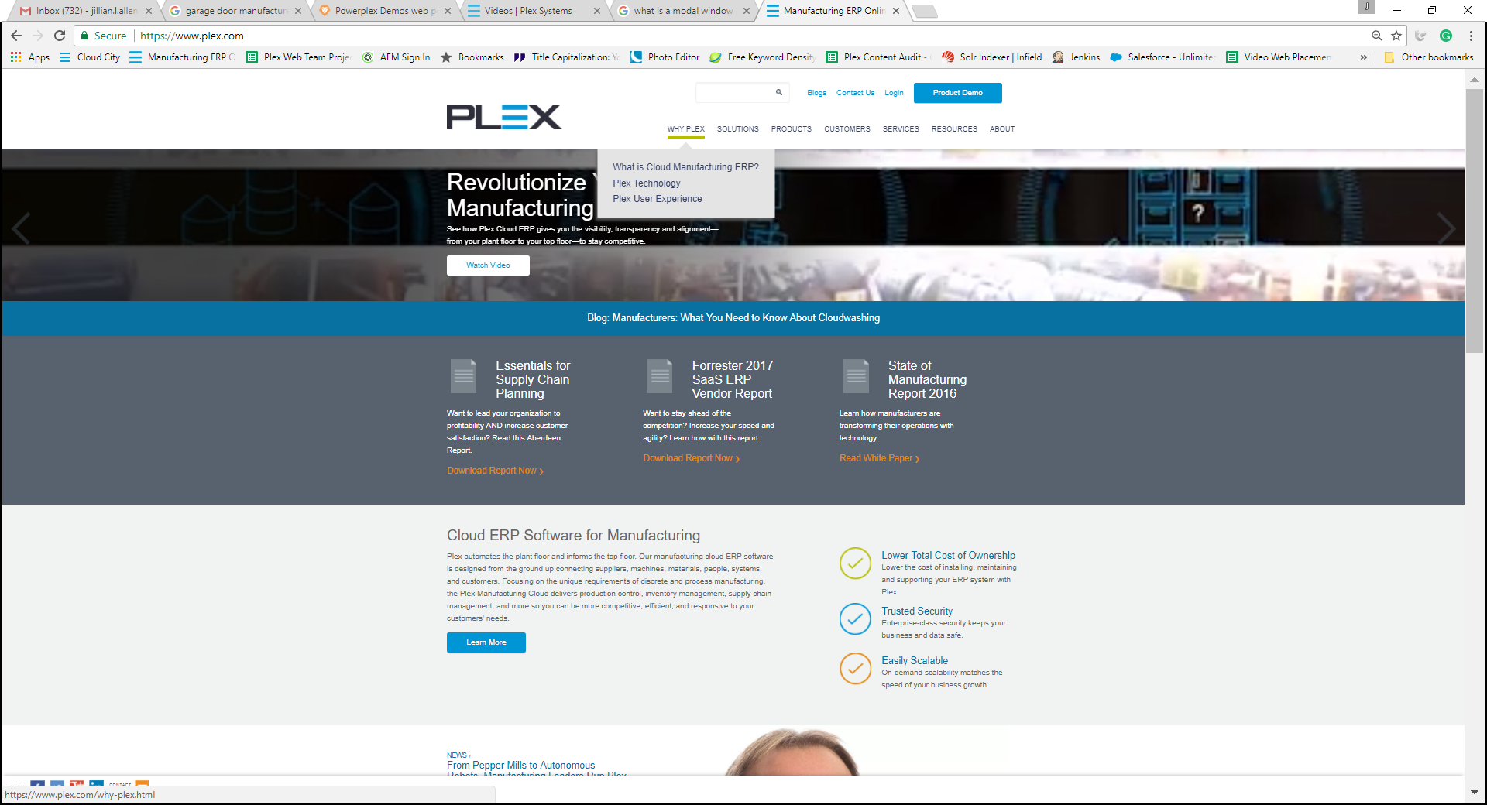



**Main Navigation**

Color: #0971a1

Font: Helvetica Neue Medium Size: 15px / 20px

##### :hover

Border Bottom: 4px solid # b6be00

##### Navigation Dropdown Main

Navigation Dropdown Main

Navigation Dropdown Sub

Color: #57626E

Font: Helvetica Neue Light Size: 20px / 44px

##### Navigation Dropdown Sub

Color: #929BA6

Font: Helvetica Neue Light Size: 17px / 36px

##### Navigation Dropdown:hover

Color: #0096D5

Default

**Download Case Study**

PDF(406KB)

**Download Case Study**

PDF(406KB)

**Call to Action**

Action Link Action Link:hover

**Call to Action**

Link Link:hover

Hover

Default

**Call to Action**

Hover

##### Primary Call to Action Button

Color: #ffffff

Font: Helvetica Neue Bold Size: 16px / 20px Background Color: #0096D5

##### :hover

Background Color: #0971a1 Remove dropshadow

##### Case Study Download Button

Color: #ffffff

Font: Helvetica Neue Bold Size: 16px / 20px

**File Type and File Size:** Font: Helvetica Neue Light Size: 14px / 14px Background Color: #0096D5

##### Footer Call to Action Button

Color: #E2870F

Font: Helvetica Neue Bold Size: 19px / 24px

Please refer to page 17 for the hover state of this button.

##### Action Link

Color: #0971A1

Font: Helvetica Neue Medium Size: 19px / 24px

##### :hover

Color: #0096D5

##### Default Link

Color: #0971A1

Font: Helvetica Neue Medium Size: 15px / 20px

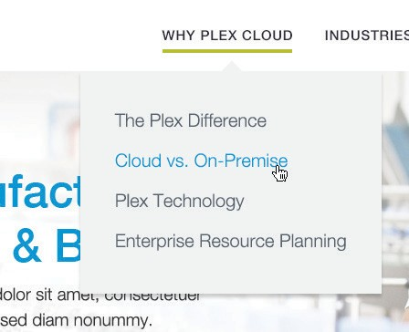HEADERS

38px

## “Lorem ipsum dolor sit amet, consectetur adipiscing elit.

Aenean congue.”

##### Pull Quote

Color: #0096d5

Font: Helvetica Neue Light Size: 34px / 48px

Vertical Rule Stroke: 5px Paragraph Inset: 38px

Page Grid

##### Column Page Grid

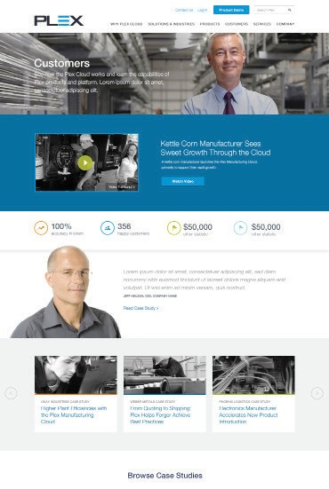

1170px

70px 30px

The Plex website uses a 12-column grid layout with 30 pixel gutters between each 70 pixel column.

~~A~~ **Heroes**



Heroes on the Plex website follow one of two formats. Details on typography styles are available in the Type Styles section.

468px

##### Home Page Hero

The home page hero is 468 pixels tall and sub-page heros are 368 pixels tall.

~~B~~ The hero contains a title, description, and a call to action button.

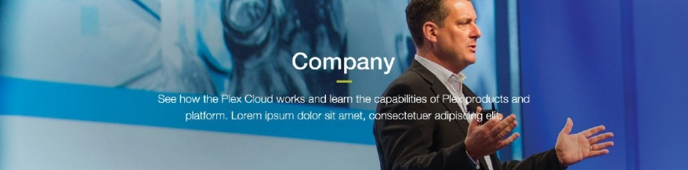

368px

##### Landing Page Hero

Used for other standard pages and its height is 368px. This hero contains a page title and summary description. It

 may also include a call to action button.



##### Resource Center Hero

368px

On the Resource Center page, the hero

~~C~~ becomes the large search field. Not sure if this is still relevant (px size and the banner being the search field.

~~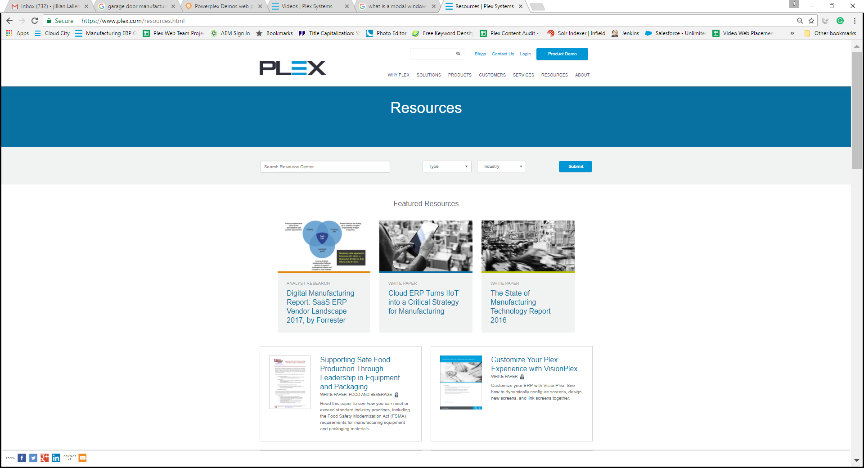~~

Default

##### Product Line Icons

These circle icons are used on the

~~A~~ product page. For the hover state, the icon is white and the color outline s solid fill of the same color.

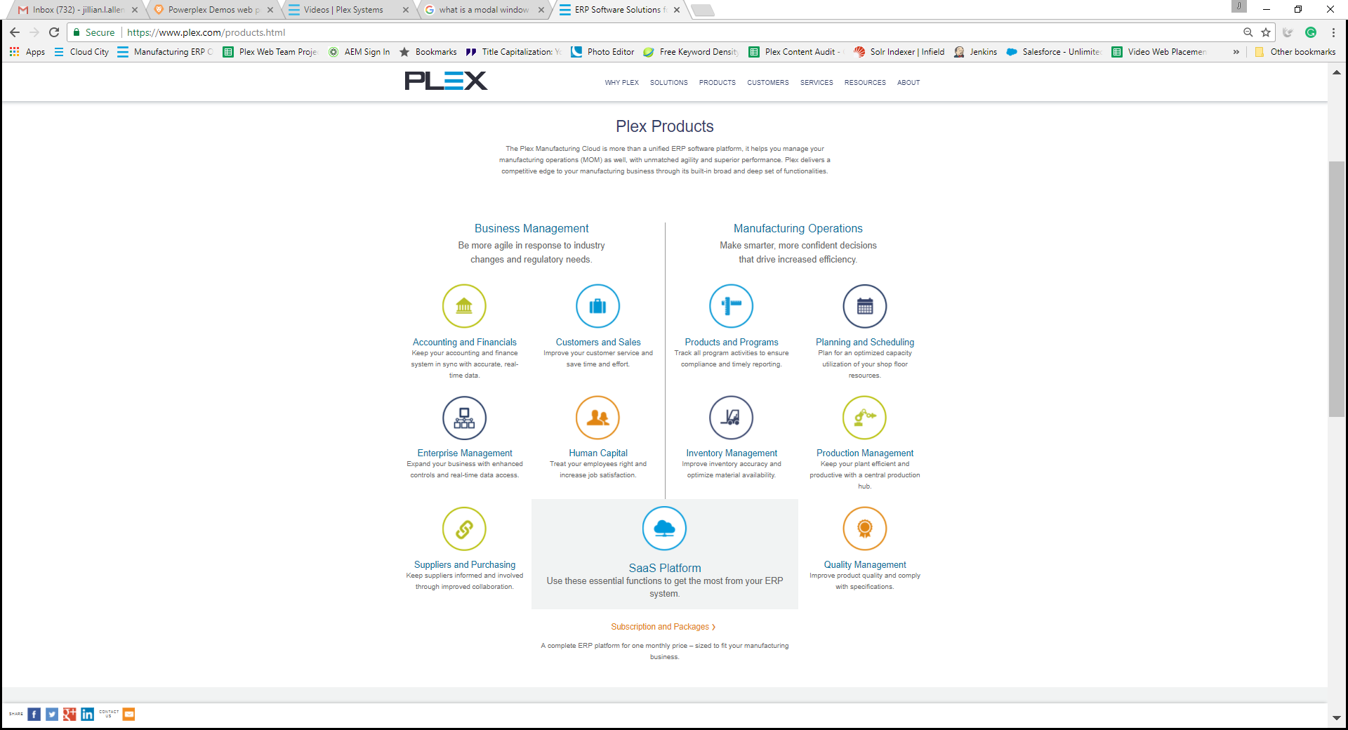 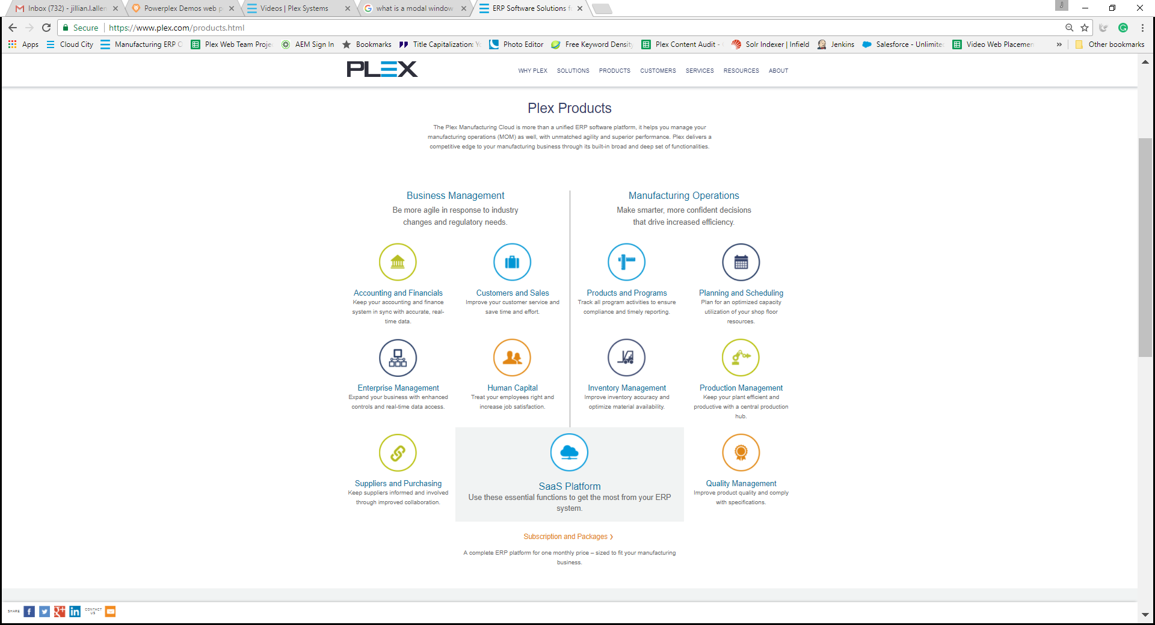

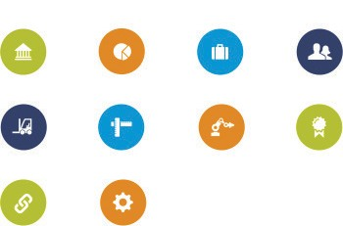

Hover

Default

Hover



Default

Hover

~~C~~

~~D~~

~~E~~



~~B~~

##### Industry Icons Large

These icons are used only on the home page, and may appear on either Plex Medium Blue or a lighter background. Plex Blue is the color used for the hover state.

1. **Industry Icons Small** These icons are used on sub-pages, and can be on a white or light background. Hover state shows light blue color.

##### Check Mark Icons

Check mark icons are used in the check list module. These icons do not have a hover state

##### Statistic Icons

Statistics icons are used with the statistics module. These icons do not have a hover state.

##### Photography

Photography on the Plex website is selected to conform to one of several different styles, depending on where the photography will be used.

##### Subject Matter

* 1. People or machines in industrial settings that relate to Plex target industry and audience base.
  2. Devices that show the Plex interface on screen or in use (desktop computers, laptop computers, mobile devices, etc.).

##### Style

Select naturalistic imagery with a clear focal point (person, machine etc.). Avoid “stock” looking images in favor of real settings with real people rather than models. Backgrounds should be simple and avoid visual clutter. Depending on where the image will be used on the site, it should allow placement of text without obscuring legibility.

 ~~A~~ **A. People Oriented Banner** Banner photography that focuses on people should feel naturalistic with a center of focus on one or more people towards the right side of the image.

The setting should be industrial but not busy. If possible the accent colors of the image should reflect the Plex palette.

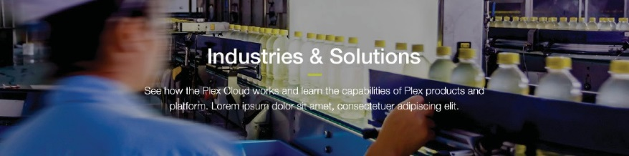 ~~B~~ **B. Industry Oriented Banner** Banner photography that focuses on industry or corporate imagery should be dynamic and draw the eye across the image. The focus of the image should be on the setting rather than people who appear in it. If possible the accent colors of the image should reflect the Plex palette.

**C. Product Oriented Banner** Banner photography that focuses on Plex products should feature a color

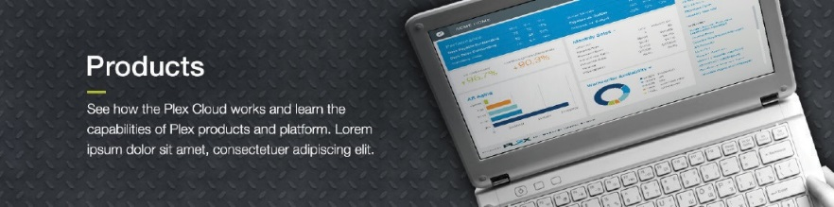 screenshot of a Plex product on a

C

monochrome laptop or similar device

against the stamped metal background.

 ~~D~~ **D. Standard Video**

For most videos on the Plex website, the thumbnail for the video should feature a monochrome still from the video. Videos display in a 16:9 aspect ratio.

##### Demo, How-To Video

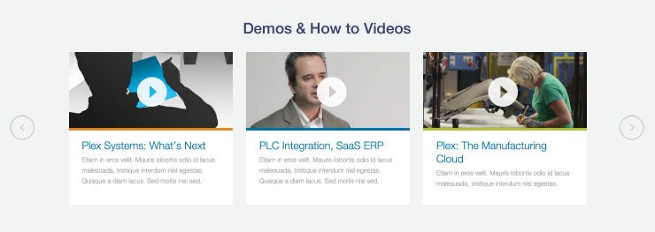 ~~E~~ For Demo and How-To videos on the Plex website, the thumbnail for the video should feature a full-color still from the video.

##### Case Study Carousel

For photography used in the Case Study carousels, high-contrast, monochrome images should be used.

~~F~~ Images that prominently feature people are preferable.

##### Office Carousel

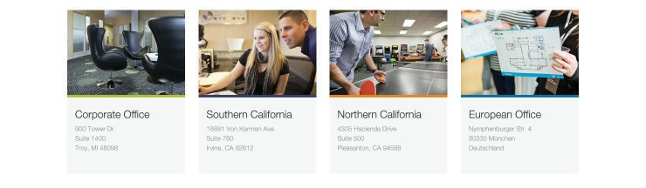For photography used in the Office

~~G~~ Location carousel, relevant color images should be used. Images that prominently feature people are preferable.

##### Case Study Hero

Photography used in the hero section

~~H~~ of individual Case Study pages should be relevant high-contrast monochrome images with a single element highlighted with a blue duotone.

##### Industries Hero

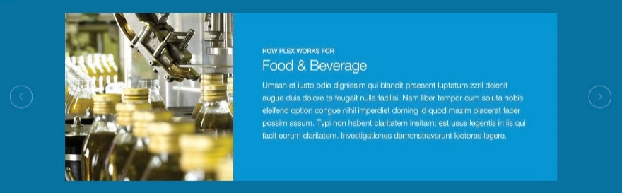Photography used for the hero carousel

~~I~~ on the Industries page should be full color images reflecting the relevant industry. If possible the accent colors of the image should reflect the Plex palette.

##### Module Background

Each module’s background color is flexible (either Plex Medium Blue, Light Gray, or White, but the same colors should not appear adjacent to each other.

##### Carousel

~~A~~ The carousel can be used to present videos or case studies and normally includes between 3 and 6 items. When more than 3 items are included, scroll arrow buttons should be used to indicate more content is available by clicking to view previous or next item.

When using only one or two items, the display changes to a static horizontal layout with the photograph or video thumbnail to the left and content to the right.

Default

Hover

###### 

Default

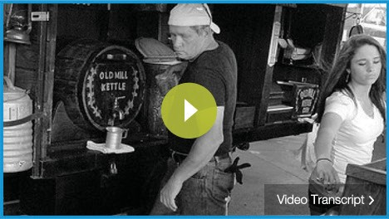

Default

B

Hover

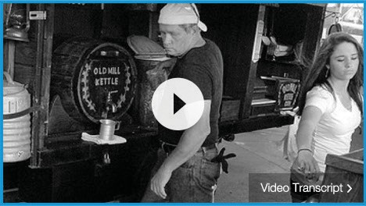 ~~C~~

Hover

 ~~D~~

 ~~E~~

##### Video Module

The video module uses the Plex Medium Blue background color and the primary call to action button. This module may also be used to contain two videos.

1. **Monochrome Thumbnail** The default state for the play icon is 80% Plex Green. For the hover state, the icon is 80% white.

##### Color Thumbnail

The default state for the play icon is 80% white. For the hover state, the icon is 100% white.

##### Resource Links Module

This module is used to display Resources links and cross-links to other related pages, and may contain either 2 or 3 blocks of content.

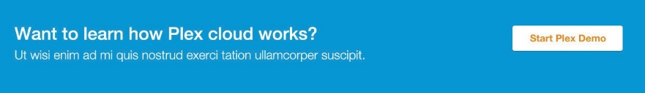 ~~F~~

Hover





 ~~G~~

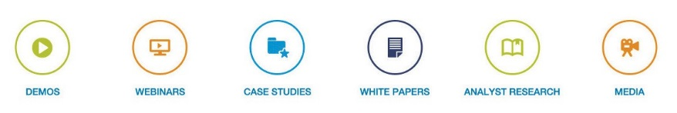 ~~H~~

##### Call to Action Module

This module is used to display calls to action in the footer section of the page, and may contain either 1 or 2 blocks of content. For the hover state, the button text color changes to Plex Blue.

##### Statistics Module

The statistics module is used to display numerical data. Use statistics icons that suit the character of the data.

1. **Sub-Category Links Module** The Sub-Category Links Module is used to display links to sub-pages. It appears in the main content area of landing pages.

##### I. Product Lines Module

I

The product lines module is used to

display core product categories and link to category detail pages. The preferred layout is 4 items per row, but in cases where there are only 2 items in a row, a call to action module may be substituted for the other 2 items.

##### Industry Links Module

~~J~~ This module is used to display links to Industry detail pages on landing pages. It uses the blue industry icons which correspond to particular industries.

When there are more than 6 industries to display, use the “Learn More” call to action button to link to a list of all related industries.

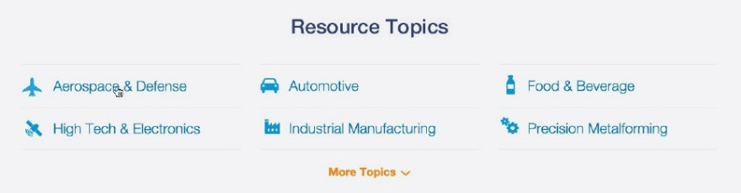 ~~K~~

##### Industry Module (Alternate)

Where space is limited, this module may be used to display links to industry detail pages. It uses the small blue industry icons.

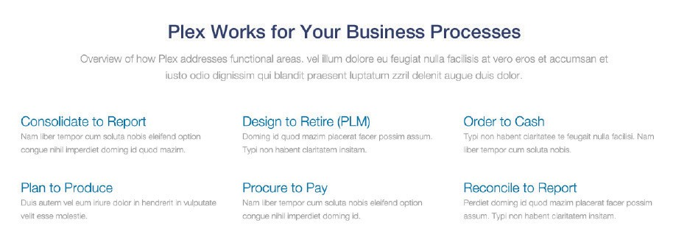 ~~L~~ **L. In-page Links Module**

This module has three columns, with headers that are links or static text. It may also include an optional primary call to action button (not shown) below the links.

##### ~~M~~ M. Check List Module

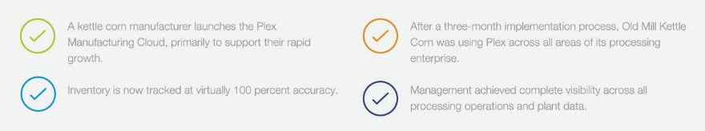This module is used to display product or service benefits and links to related content, and may use either a two or three-column layout. Use the check list icons and arrange so that icons of the same color do not appear adjacent to each other.

 ~~N~~ **N. Featured Content Module** This module is used to highlight topics on a landing page and provide links to sub pages, and incorporates a relevant photograph as the background image. See the Photography section for more detail on selecting appropriate images.

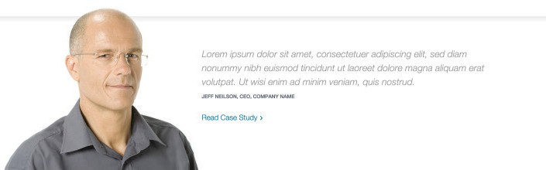 ~~O~~ **O. Featured Case Study** This module is used to call out and highlight specific case studies in

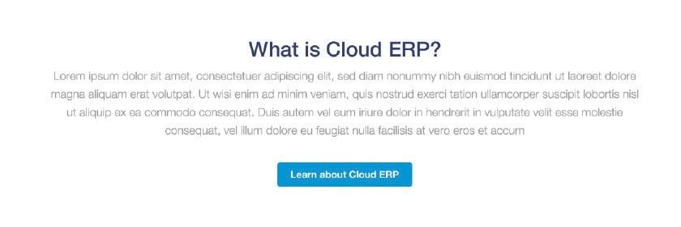contextually relevant locations. Portraits may be used in combination with pull quotes and links to full case studies, but should be of professional quality and have the subject cropped out of the background.

~~P~~

##### Summary Module

This module is used to provide a concise summary of the page content and should be limited to one paragraph. It may contain an optional “Learn More” primary call to action button.

##### Text Content Module

~~Q~~

This module is used to display body

copy, pull quotes, and images. The background color for this module is always white.

**PLEX WEBSITE STYLEGUIDE**

Page 21

*Prepared byPlex Systems | Confidential*

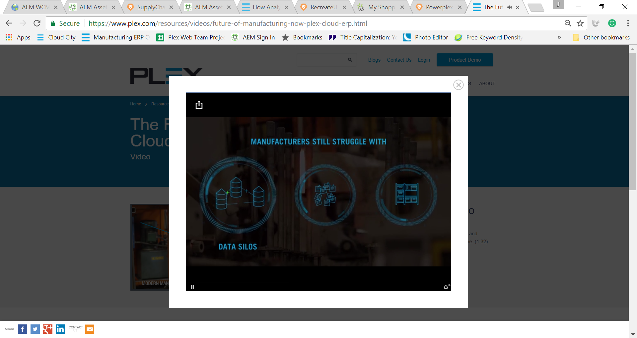

##### ~~A~~ A. Video Player Overlay

The video player overlay is a modal window used to display the videos, and includes a share and close button. In the case of embedded video content (i.e. Vidyard) do not include the title or author of the video when publishing.

These options should be omitted when copying the embed code.

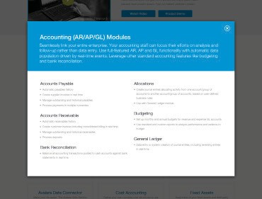 ~~B~~ **B. Content Overlay**

This modal overlay is designed to display detailed information about a particular topic without taking the

viewer away from the page. The header background is Plex Blue with white headline and copy type.

##### C. Leadership Overlay

C

This modal overlay is used to present

the bios and photos of members of the Executive Team on the Leadership page. The layout is similar to the Content Overlay and is consists of a Plex Blue header and white body. Executive portraits are three-quarter length. The photos should be of professional quality and have the subject cropped out of the background.

**PLEX WEBSITE STYLEGUIDE**

Page 22

*Prepared by Plex Systems | Confidential*